**Waste Table 1–Diverting operational waste from landfills and incinerators**

In FY23 we diverted more than 18,500 metric tons of waste from being landfilled or incinerated across our owned datacenters and campuses.

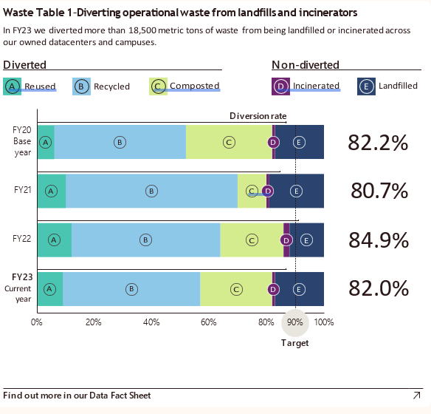

Horizontal stacked bar graph showing the percentage of operational waste diverted from landfills and incinerators over fiscal years FY20 to FY23. Diverted waste categories include Reused, Recycled, and Composted, while Non-diverted waste includes Incinerated and Landfilled. The diversion rates for each year are FY20: 82.2%, FY21: 80.7%, FY22: 84.9%, and FY23: 82.0%. Recycled waste comprises the largest percentage, followed by Composted and Reused materials. Landfilled and Incinerated waste make up smaller proportions throughout. FY20 serves as the base year, with FY23 as the current year. 90% is marked as target.